1. Create a new folder called ASLtoEng
2. Download “Action Detection Without Face.ipynb” from github and put it in the folder
3. Open that notebook in jupyter
4. Install mediapipe dependency by running cell 1 as well as other dependencies you need
5. Run all the cells up until “5. Manual data collecting” and start collecting (Run the 4th cell to test that opencv works)
6. Note:
   1. 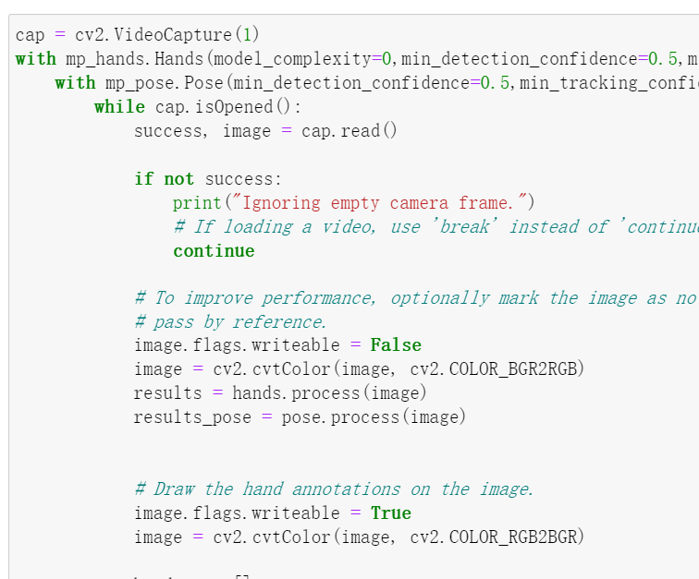
   2. Cv2.videocapture() takes in your camera number. Try other values like 0 or 1 if yours don’t work
   3. You have 30s before the collection of the next action so you can watch youtube videos and remember how to sign the next vocabulary